SITE PHOTOS

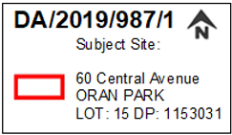
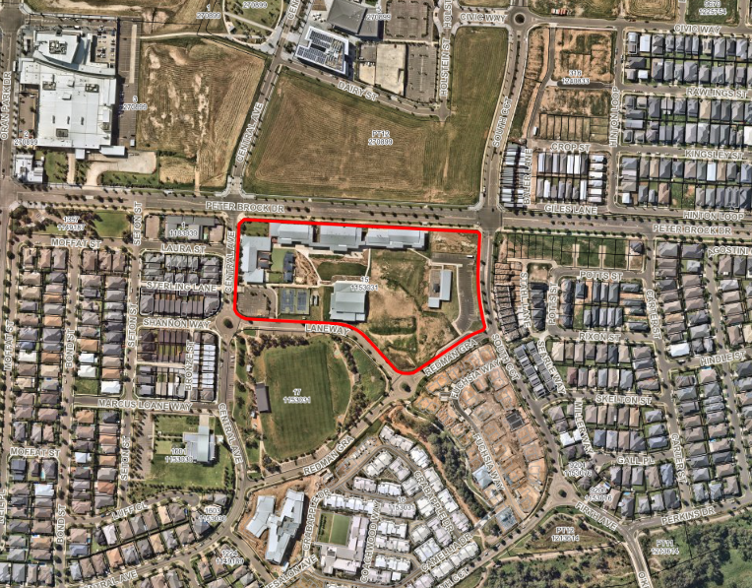
Figure 1: Aerial Photograph of the development site

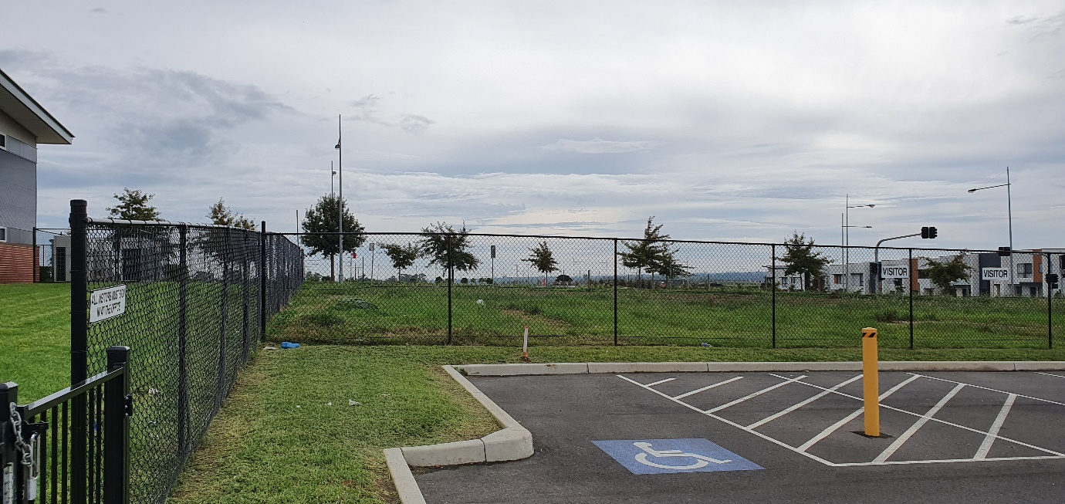
Figure 2: Looking North from the existing car park toward Peter Brock Drive
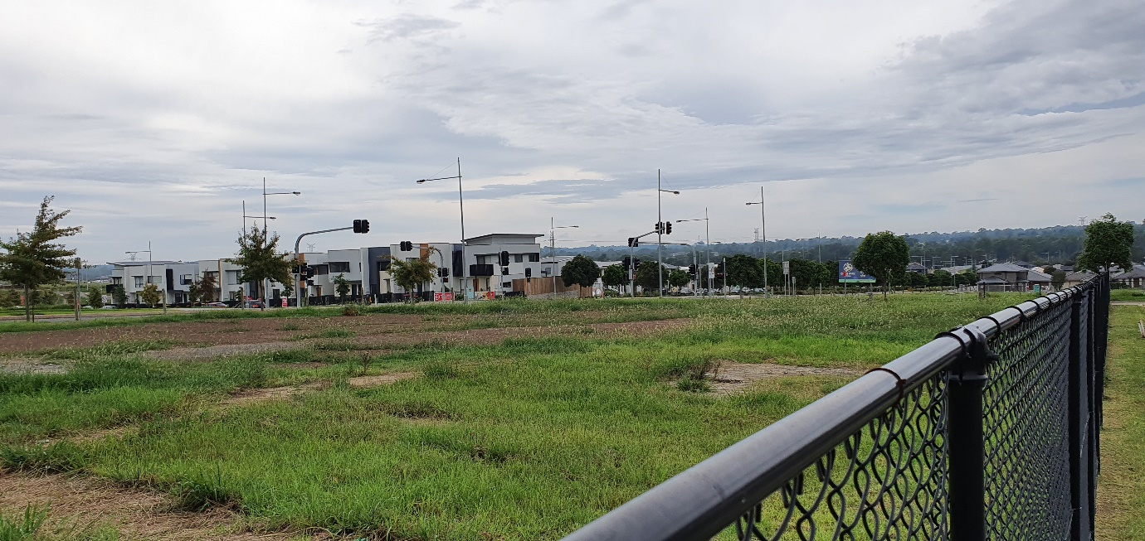
Figure 3: View from the South West Corner toward intersection on Peter Brock Drive and South Circuit
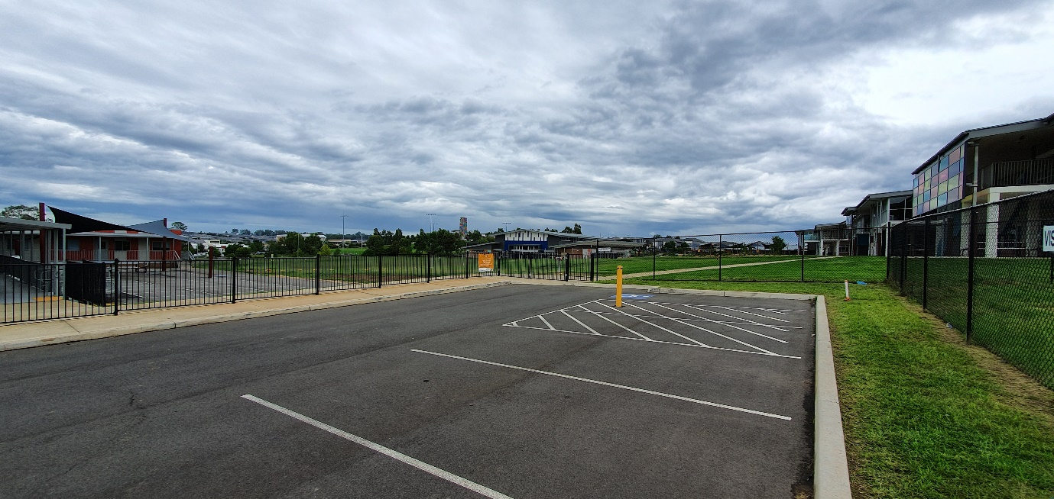
Figure 4: Looking South West towards the already constructed school campus.
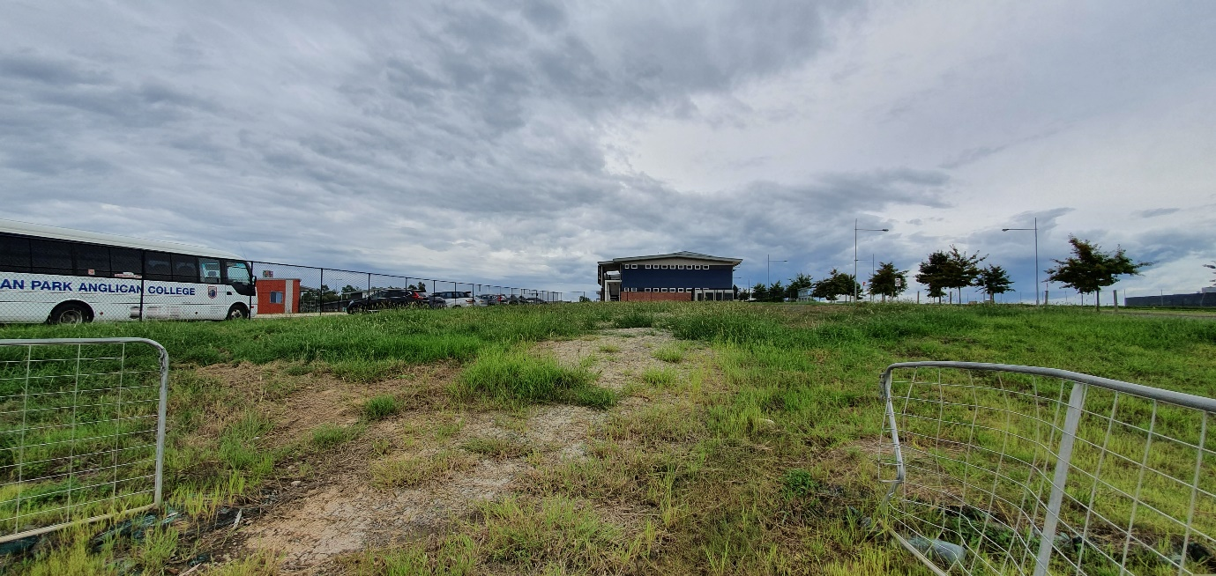
Figure 5: Looking West uphill toward the existing school campus

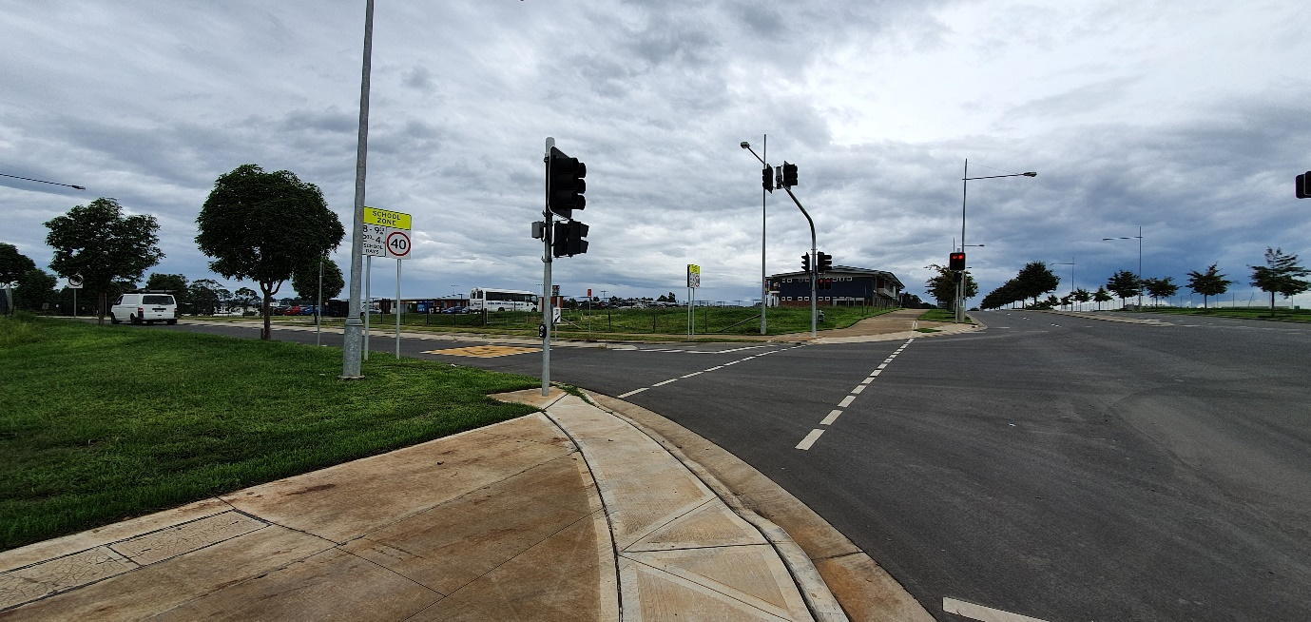
Figure 6: Looking West toward the school campus from intersection on Peter Brock Drive and South Circuit
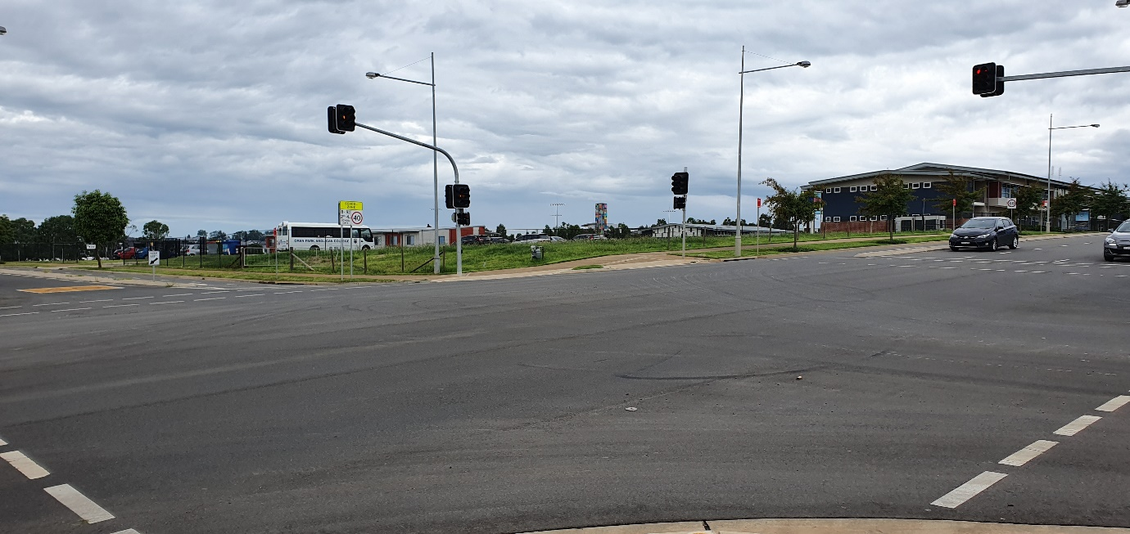
Figure 7: View looking South West across toward the corner of the development site
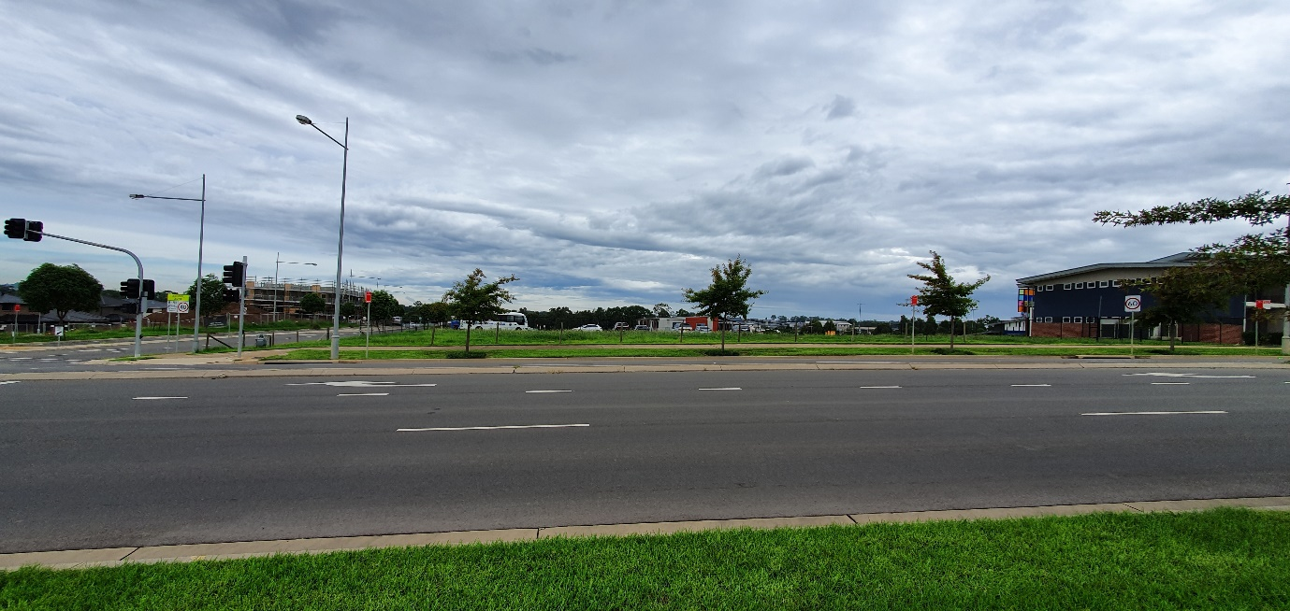
Figure 8: Looking South across Peter Brock Drive toward the development site
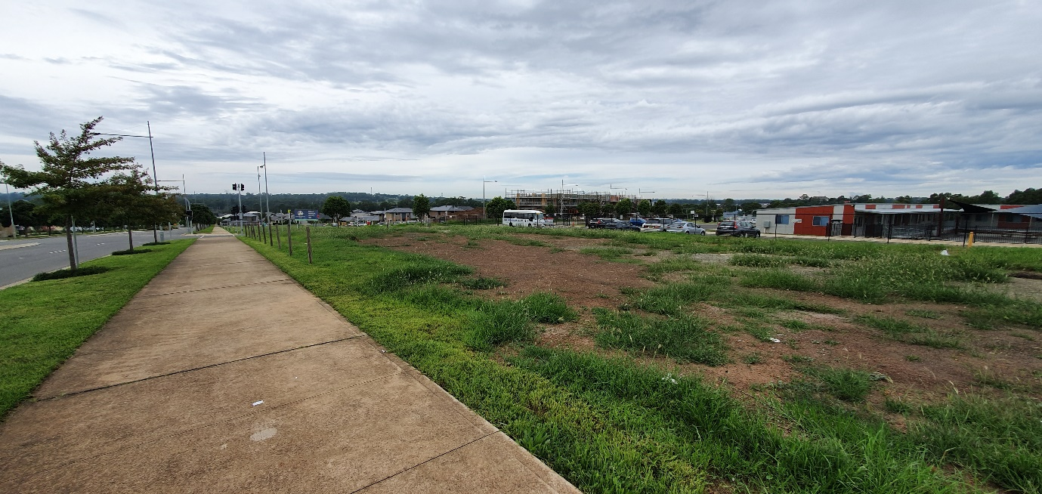
Figure 9: View of the development site looking South East
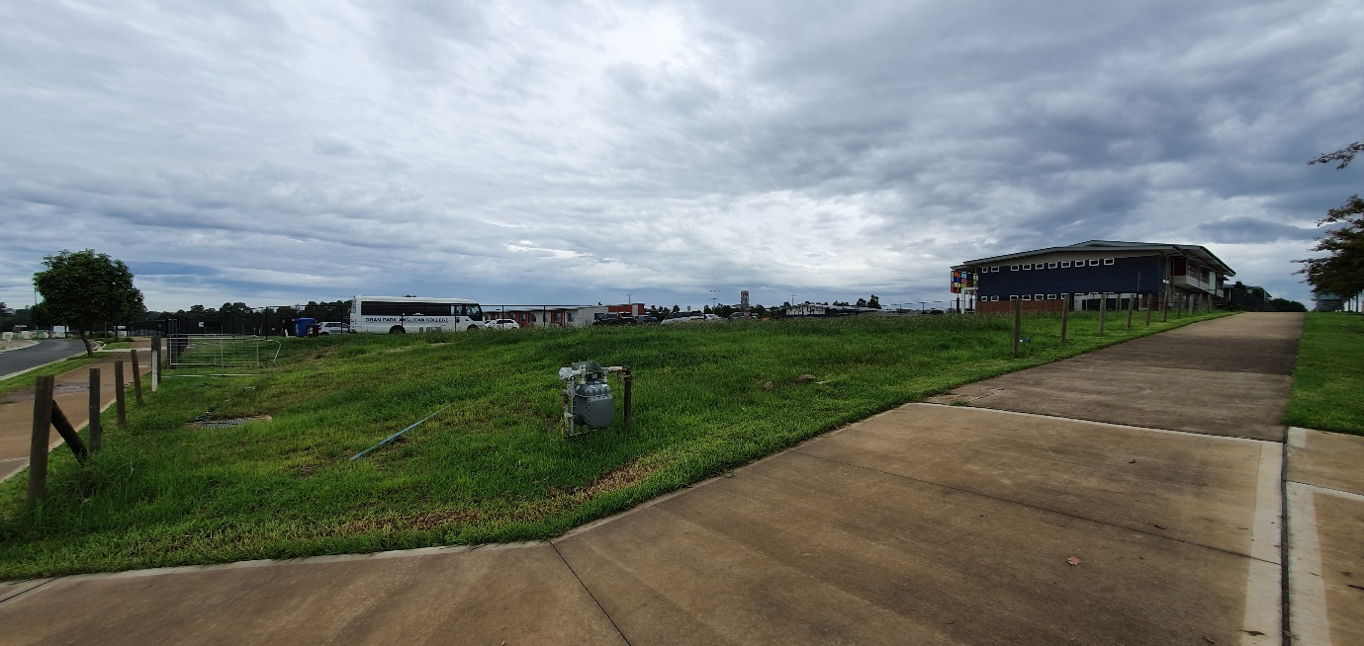
Figure 10: Looking South West from the footpath across the development site.

